**Jukebox**

### **What is it?**

Make a music machine that plays different tunes at the push of a button.

### **How it works**

* A jukebox is a machine that plays different songs when you put a coin in and choose which tune you want to hear by pressing buttons.
* This micro:bit jukebox uses headphones or speakers connected to make sound like we did in the Make some noise project.

## **Step 1: Build it**

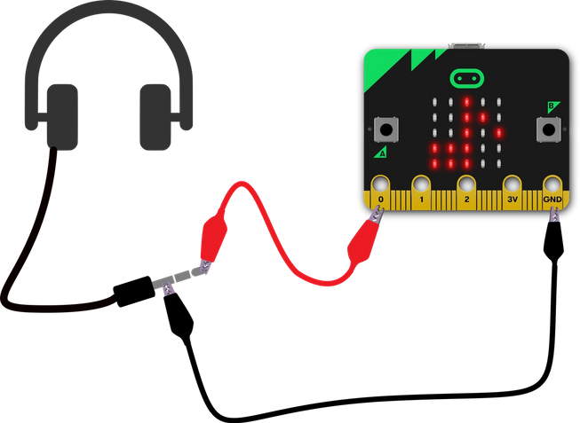

* Connect micro:bit pin 0 to the tip of your headphone plug, and GND to the longer part of the headphone plug.
* When you make sound with the micro:bit, pin 0 becomes an **output**.
* This program plays different built-in tunes if you press [input button A or button B](https://microbit.org/get-started/user-guide/features-in-depth/#buttons).
* Note: If you have a version 2 Micro:Bit, you can use the built-in speaker instead of headphones.

### **What you need**

* micro:bit (or MakeCode simulator)
* MakeCode or Python editor
* battery pack (optional)
* a pair of headphones, buzzer or amplified loudspeaker
* two crocodile clip leads

## **Step 2: Code it**

## **Step 3: Improve it**

* Change the tunes, for example try PRELUDE or ENTERTAINER. You can find a list of all the built-in tunes you can use in Python [here](https://microbit-micropython.readthedocs.io/en/latest/tutorials/music.html).
* Show different pictures, letters, numbers or words depending on which tune you picked.
* Make it play a random tune if you shake it.